The 5 items of work that have been chosen for this portfolio include the following:

* Provider's Database Information
* Application Layout Design
* BurnDown Chart / Sprint Planning
* Programming
* External Program Feedback

1. Overall these 5 pieces of work show how I have assisted the team from an Information Systems point of view. In order for the application to work succinctly we needed to create a database with information from current providers such as locksmiths, plumbers and electricians. This was data was imperative for the application to make sense when it is tested. The following image depicts a small portion of the data in an excel spreadsheet illustrating some of the providers that I compiled for the application.

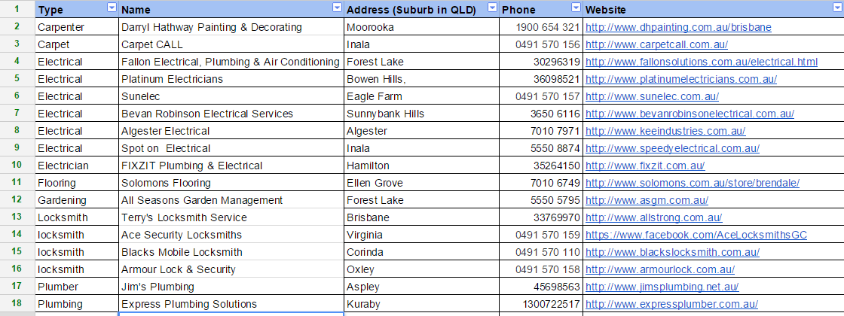

1. When the program was being created in the early stages, it was important that we understand how each page is going to look like; myself and the other information systems student broke down how pages were going to look like. Below is four hand drawn screen that I created in order to help the programmers understand the layout.

12048940_10206430619717027_1006857112_n.jpg12030736_10206430619837030_1103164324_n.jpg11998514_10206430619637025_172026632_n.jpg12015334_10206430619997034_1031386984_o.jpg

1. Throughout the last 5 - 6 weeks, there has been much planning and development around both sprint 1 and sprint 2. It became evident that we needed to create burndown charts so that the team can assess how long tasks are expected to take and how long they actually took. I created and edited both burndown charts for the first and second sprint. I have presented an image of the burndown chart from sprint 1 below, the second burndown chart has similar structure.

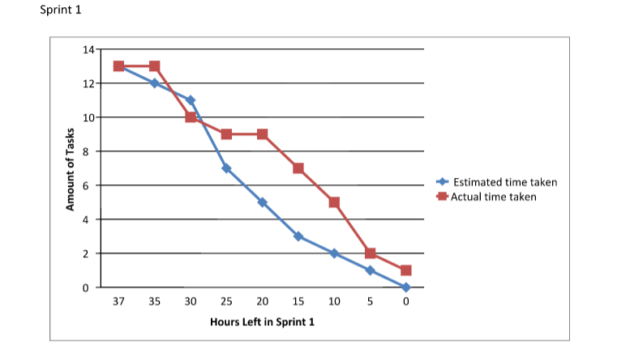

1. With the overall programming of the application, majority of coding was completed by the two computer science students however I managed to assist them with one important programming section. This section can be viewed here:

<https://github.com/MrMagic9/IFB299---The-cavalry---Help-Desk/blob/master/Helpdesk/providers_form.cs>

1. External application feedback was needed in order to see if our program made sense to users who were unfamiliar with the program. Myself along with the other information systems team member spoke to friends and family and showed them the program. We viewed this as a type of testing to see if the application was easy to use and if their improvements were similar to the clients specifications. I explained the program to my friends and told them the purpose of the program and what it is suppose to do. After this I got them to use the program and I recorded their feedback. Below is one of the individuals feedback of the program.

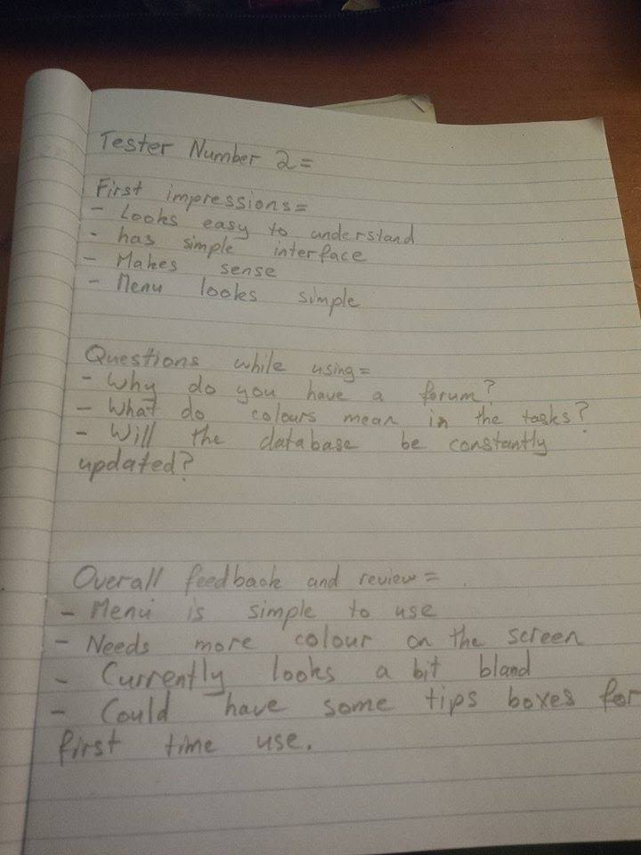

Overall I felt that these five pieces of work have demonstrated how I have contributed to the team via planning, coding, data entry, time management and design.